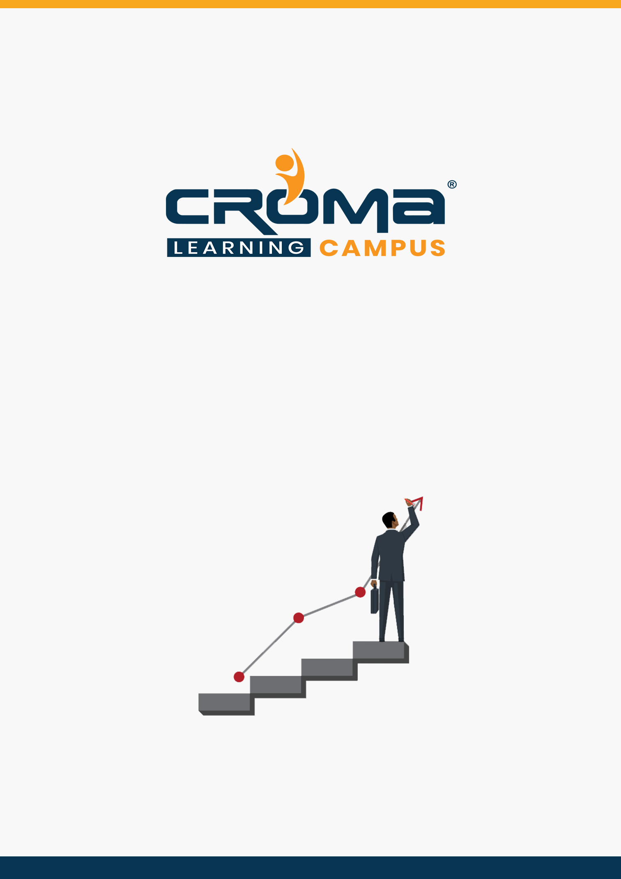

**Salesforce Lightning Training Curriculum**

**STRUCTURE**

**www.cromacampus.com | helpdesk@cromacampus.com | +91-120-4155255**

**Salesforce Lightning Training Curriculum**

*“Give an edge to your career with comprehensive Salesforce Lightning Training Course at Croma Campus.”*

**About Croma Campus:**

Croma Campus Training & Development Private Limited is an education platform since 2010 providing rigorous industry-relevant programs designed and delivered in collaboration with world-class faculty and industry.

* Hands-On Live Projects
* Simulation Test Papers
* Industry Cases Studies
* 61,640+ Satisfied Learners
* 140+ Training Courses
* 100% Certification Passing Rate
* Live Instructor Classroom / Online Training
* 100% Placement Assistance

**Course Objectives:**

* Know About Salesforce Lightning Fundamentals.
* Salesforce Lightning Apps and Components
* Surfacing Salesforce Lightning Components
* Designing Lightning Components & Implementing Navigation/Layouts
* Building Advanced Components
* Working with Data
* Theming your Apps

**Course Description:**

Salesforce Lightning will create a dynamic revolution in 2020 by tremendous developments and technology advancements. According to the recent survey conducted by top job portals, it is evident that there is a huge requirement for Salesforce admins and developers all over the world. Certified Salesforce administrators earn an average salary of $87,000 USD per annum. But, depending on their knowledge, skills, and experience their salary might increase up to $160,000.

This course develops your coding skill set to the next level. The lightning components provide an out-of-the-box set of components that allows building applications, event-driven architecture providing decoupling between components, and a framework optimized for performance by utilizing the server, browser, network, and devices.

Enroll in this course to gain programming experience using Lightning Components, JavaScript, CSS, Apex, and the Salesforce Lightning Design System (SLDS), and deploy them successfully for use by Salesforce end users.

**Croma Campus Training Program Deliverables:**

* **Session Recordings** - Original Class Room Voice & Video Recording
* **Training Material** - Soft Copy Handbooks
* **Assignments** | 25+ Hands-on Exercises
* **Test Papers** - We provide **Practice Test** as part of our course to help you prepare for the actual certification exam.
* **Live Case Studies**
* **Live Projects** - Hands-on exercises and Project work. You will work on real time industry-oriented projects and assignments for each module to practice.
* **Key focus on Hands-on exercises and Project work**. You will work on real time industry-oriented projects.
* Faculty with more than **10+ Years of Experience** in the Industry.
* **Technical Resume Designing & Job Assistance:** With more than 100+ Clients across the Globe and we help learners to get a good job in their respective field. We also help learners with resume preparation.
* **Interview Q&A**
* **About Croma Campus Training Certificate:** Croma Campus will provide you with an industry-recognized (Certified by **ISO 9001:2015** & **E-Cell IIT Jodhpur**) course completion certificate which has lifelong validity.
* **How I Unlock my Croma Campus Certificate:** Attend Complete Batch & Submit at least One Completed Project.

**Course Content:**

**Module 1: Introducing Lightning Components & Applications**

* Using HTML5 and Lightning Components to Develop Apps
* Defining a Lightning Component
* Defining and Manipulating Component Attributes
* Handling User Events
* Using Helpers for Complex Client-Side Event Handling
* Documenting a Component
* Using OOTB Lightning Input Components
* Working with Apex
* Debugging and Troubleshooting Your App
* Testing and Troubleshooting Apex

**Module 2: Surfacing Lightning Components**

* Surfacing lightning component
* Building Lightning Pages with Components and App Builder
* Building Components for Lightning Experience Record Pages

**Module 3: Designing Lightning Components & Implementing Navigation/Layouts**

* Defining a Lightning Application
* Using Lightning Components in Visualforce Pages with
* Lightning
* Installing and Managing Components from AppExchange
* Packaging a Component for Distribution
* Using<lightning:tabset>
* Implementing Button Groups
* Implementing a Deck of Cards Layout
* Using the Grid System
* Implementing Menus

**Module 4: Building Advanced Components**

* Accessing the Component Body
* Dynamically Instantiating and Destroying Component Instances
* Localizing Content
* Defining and Handling Nested Sub-tags
* Raising Events and Defining Public Methods
* Raising Salesforce1 Events
* Using Renderers
* Writing Device-Specific Code
* Using Inheritance

**Module 5: Working with Data**

* Implementing Forms
* Validating Input Data
* Implementing a Query-by-Example System
* Viewing and Editing Salesforce Records
* Waiting for Server Requests to Complete

**Module 6: Theming your Apps**

* Applying Colors and Typography
* Theming with Lightning Tokens
* Project allocation

**Module 7: Placement Guide**

* Tips to clear an Interview
* Common Interview questions and answers
* Salesforce Lightning Interview Questions and Answers
* Resume Building Guide
* Career roadmap and certifications
* Attempt for the related Global Certification Exam
* Start applying for Jobs